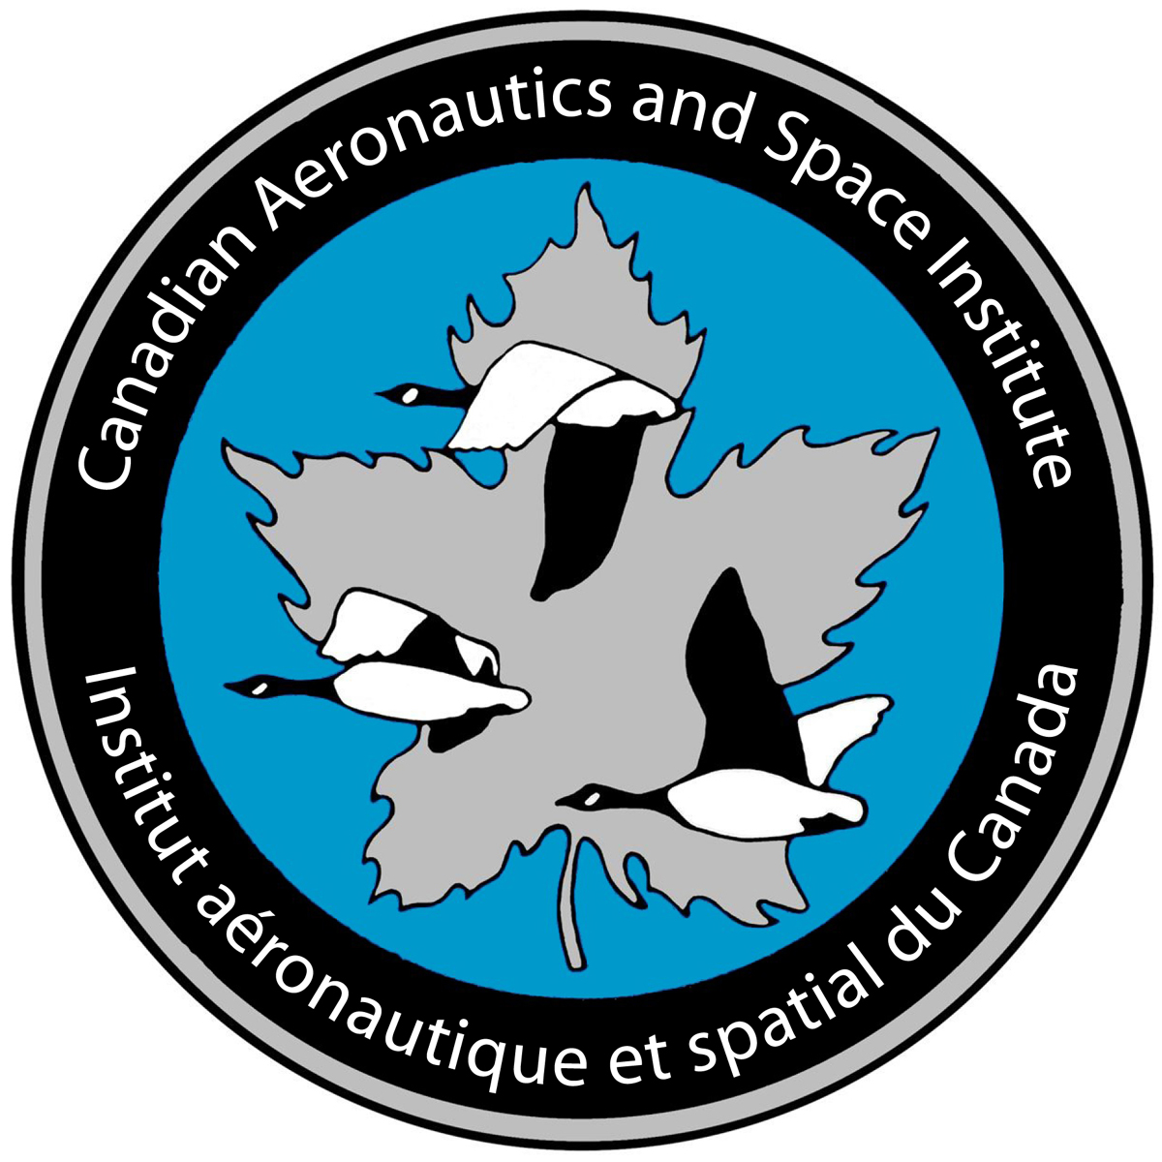 | Nomination for Advancement to Associate Fellow

Nomination for Advancement to Associate Fellow
An Associate Fellow shall have been engaged for not less than ten years in the practice of research, engineering, manufacturing, planning, administration, maintenance, operations or other work relating to aeronautics, astronautics, associated technologies and their applications; and shall have been in charge of important work and made significant contributions in his or her field of endeavor.
Two members of the Institute at member level or higher, one of whom must be at the level of Associate Fellow, Fellow, Honourary Fellow or Councillor, may nominate for advancement in grade to Associate Fellow a member who, in their opinion, meets the requirement above, provided that the permission of the nominee has been obtained.

Candidate’s Personal Information
First Name: | Last Name: |  | CASI Member #:
Organization: |  | Title:
Address:
Home Phone: ( ) - | Bus Phone: ( ) - |  | Email:

Nominator’s Personal Information
First Name: |  |  |  | Last Name:
Organization: |  |  |  | Title:
CASI Member #: | Grade: |  | M |  | AF |  | F | HF
Address:
Home Phone: ( ) - |  | Bus Phone: ( ) - |  |  |  | Email:

Nominator’s Personal Information
First Name: |  |  |  | Last Name:
Organization: |  |  |  | Title:
CASI Member #: | Grade: |  | M |  | AF |  | F | HF
Address:
Home Phone: ( ) - |  | Bus Phone: ( ) – |  |  |  | Email:

